Get me two data for newly creating leads in leaftaps

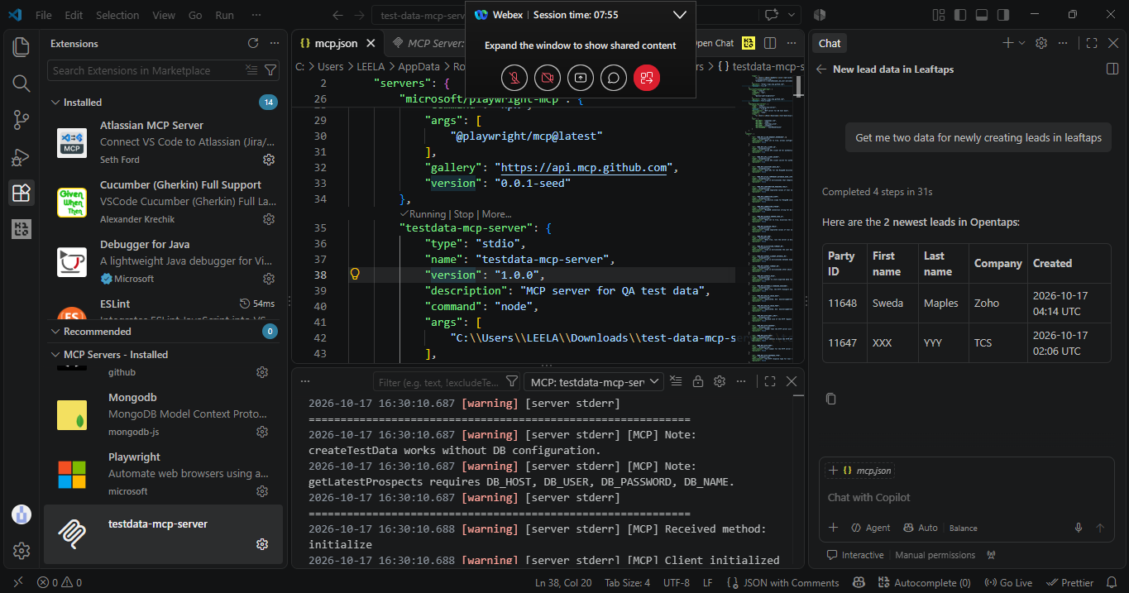
I am about to delete two records in leaf taps, Give me two led-id alone
